Final project work : Building a Data-Driven Movie
Recommendation System
Description for all code:
#Data Collection
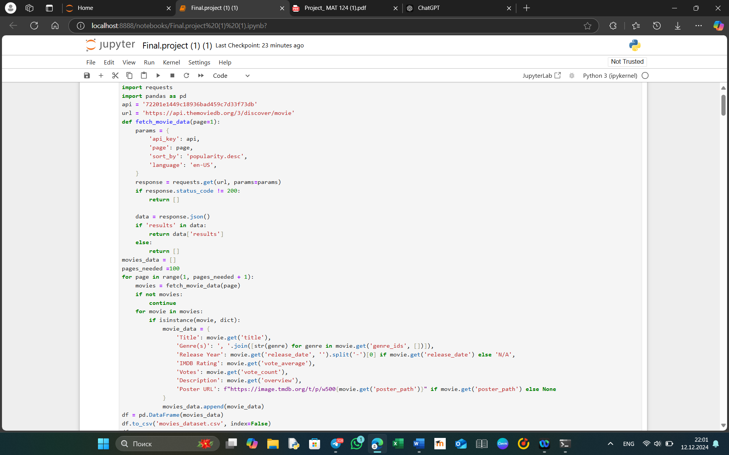
This script collects movie data using The Movie Database (TMDb) API. Key aspects of the code:
- API Requests:
  - Sends requests to the TMDb API to retrieve movie data by page using the fetch_movie_data function.
  - Each request fetches up to 20 popular movies, sorted by popularity.
- Data Extraction:
  - For each movie, details such as title, genre IDs, release year, IMDb rating, vote count, description, and poster URL are extracted and stored in a dictionary.
- Pagination:
  - Iterates over 100 pages (2,000 movies total) to collect data, appending each movie's details to a list (movies_data).
- Data Storage:
  - The collected data is saved to a CSV file, movies_dataset.csv, using Pandas for easy analysis.
This script automates the retrieval of movie data, making it suitable for building datasets for analysis or machine learning projects.

#Data Cleaning and Preprocessing
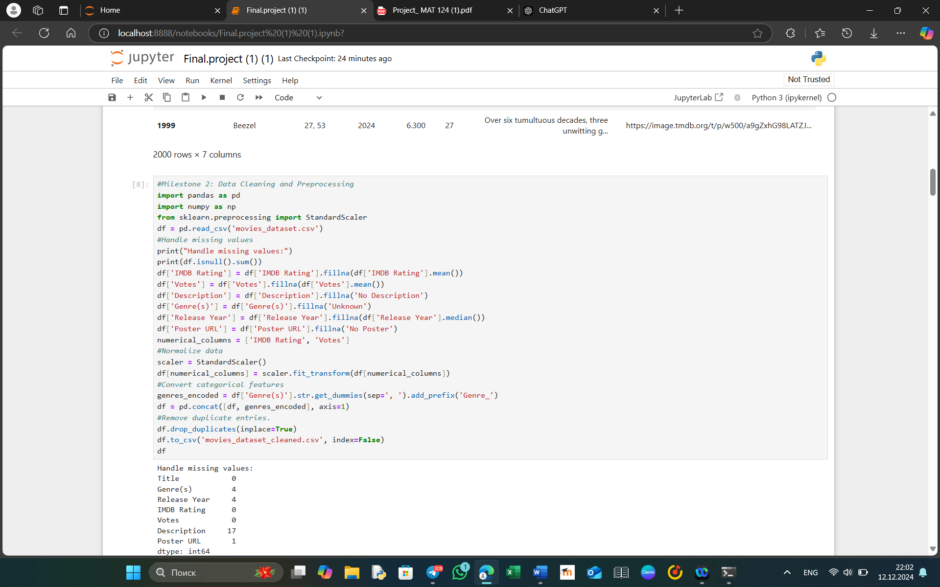
This script processes the raw movie dataset to ensure it is clean and ready for analysis or modeling. Key steps include handling missing values, normalizing numerical features, encoding categorical data, and removing duplicates.

Key Steps:
- Loading Data:
  - The dataset movies_dataset.csv is loaded into a Pandas DataFrame for processing.
- Handling Missing Values:
  - Identifies missing values using df.isnull().sum() and applies appropriate strategies:
    - IMDB Rating: Replaced with the column's mean.
    - Votes: Replaced with the column's mean.
    - Description: Replaced with the text "No Description."
    - Genre(s): Replaced with "Unknown."
    - Release Year: Replaced with the median value of the column.
    - Poster URL: Replaced with "No Poster."
- Normalizing Numerical Features:
  - Standardizes the numerical columns (IMDB Rating and Votes) using StandardScaler from sklearn. This ensures the data is scaled with a mean of 0 and a standard deviation of 1, improving performance in machine learning models.
- Encoding Categorical Data:
  - Converts the Genre(s) column into binary indicator variables using str.get_dummies. Each unique genre becomes a new column (e.g., Genre_Action), with a value of 1 indicating the presence of that genre.
- Removing Duplicates:
  - Identifies and removes duplicate rows using df.drop_duplicates() to ensure data integrity.
- Saving Cleaned Data:
  - The cleaned dataset is saved to movies_dataset_cleaned.csv, preserving all updates for further use.

#Exploratory Data Analysis (EDA)
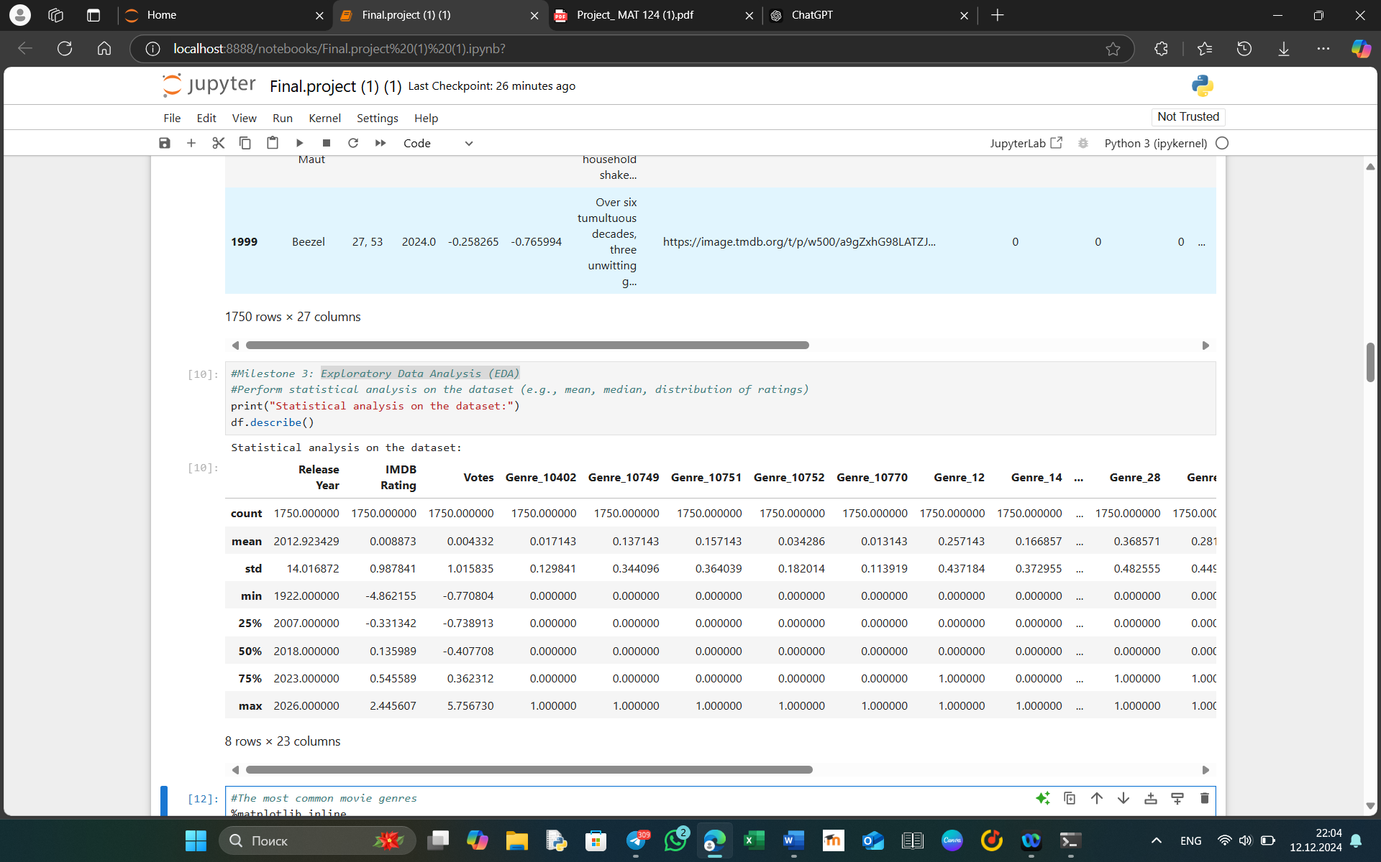
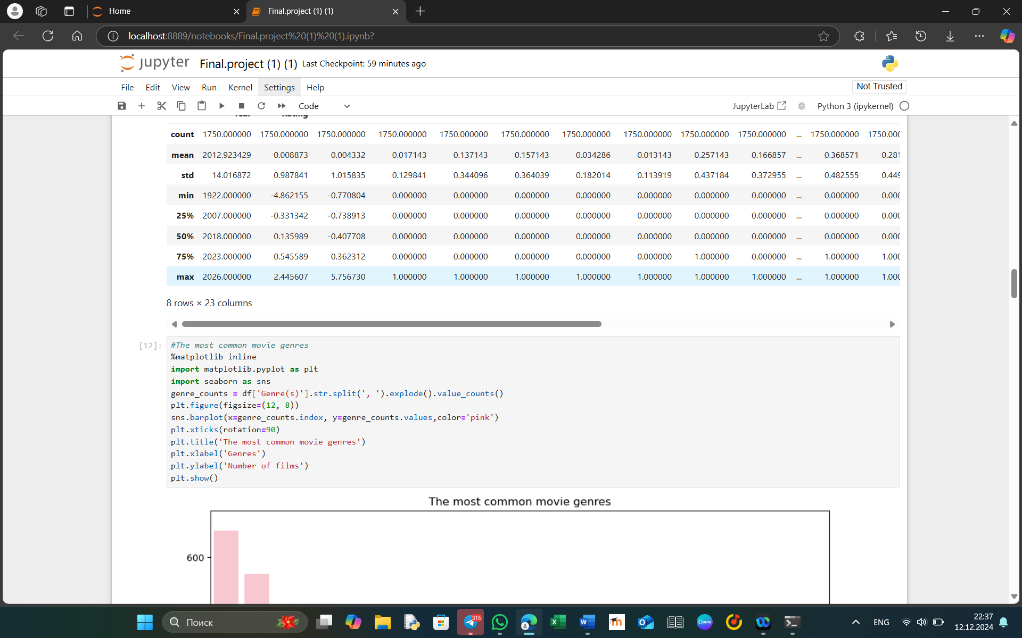
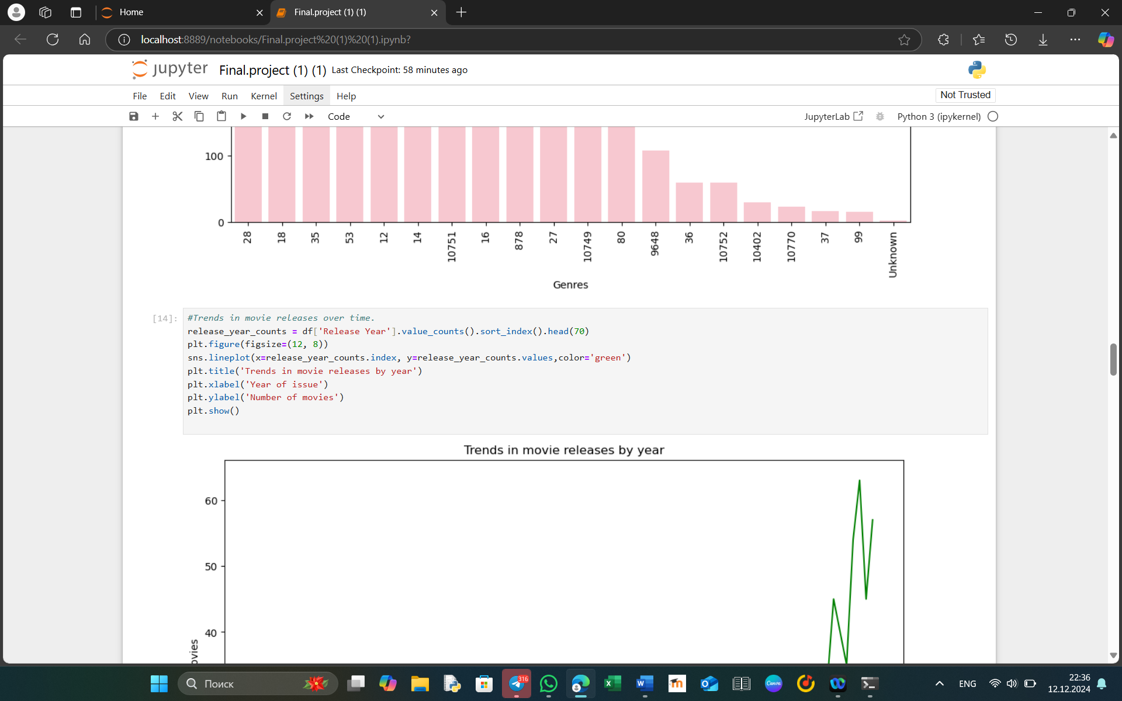
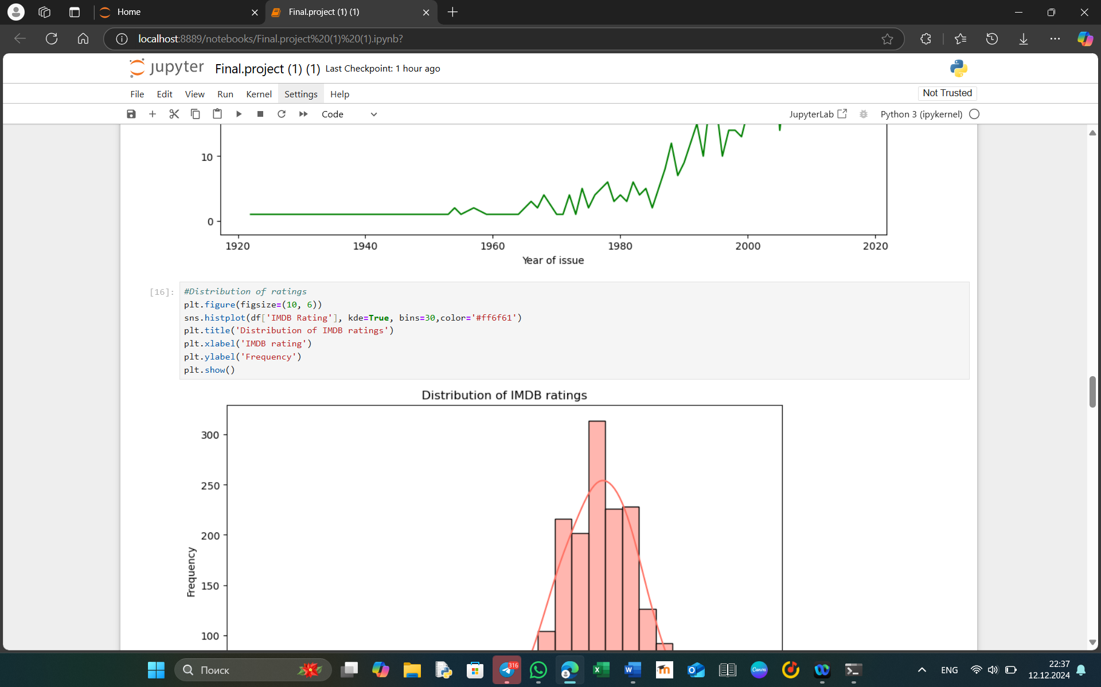
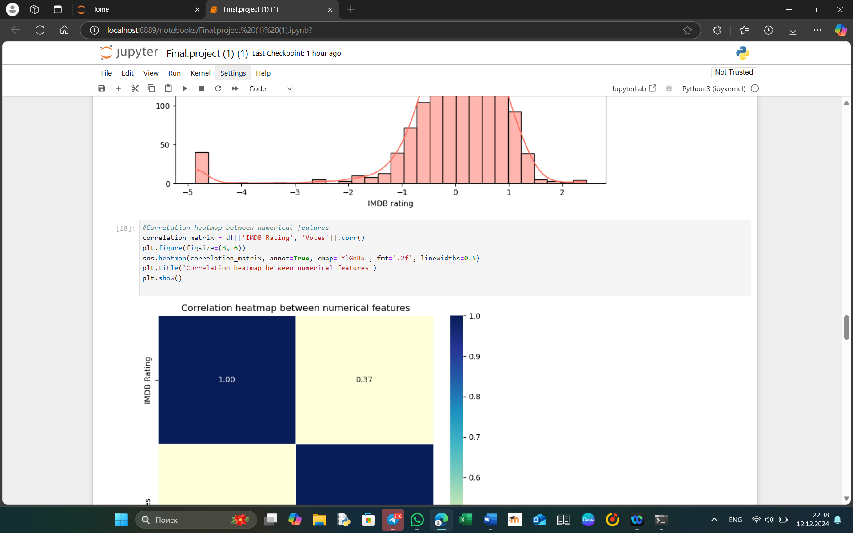
This script performs an exploratory data analysis (EDA) on the cleaned movie dataset to uncover insights about movie trends, genres, ratings, and correlations.

Key Steps:
- Statistical Summary:
  - Uses df.describe() to provide a summary of numerical features, including mean, median, standard deviation, and range.
- Analysis of Most Common Movie Genres:
  - The Genre(s) column is split into individual genres using .str.split(', ').explode().
  - A bar plot is created to visualize the frequency of each genre:
    - X-axis: Genre names.
    - Y-axis: Number of movies in each genre.
  - Customizations:
    - Rotated labels for readability.
    - Title: "The most common movie genres."
- Trends in Movie Releases Over Time:
  - Counts the number of movies released each year (Release Year) and sorts the results by year.
  - A line plot is used to display trends over time:
    - X-axis: Release years.
    - Y-axis: Number of movies released in each year.
  - Highlights changes in movie production trends over decades.
- Distribution of IMDB Ratings:
  - Creates a histogram with 30 bins to show the distribution of IMDB ratings:
    - Adds a Kernel Density Estimate (KDE) for smooth visualization.
    - X-axis: IMDB rating values.
    - Y-axis: Frequency of movies within rating ranges.
  - Title: "Distribution of IMDB ratings."
- Correlation Analysis:
  - Calculates the correlation between numerical features (IMDB Rating and Votes) using .corr().
  - Displays a heatmap with:
    - Annotations showing correlation coefficients.
    - A blue-green color palette (YlGnBu) for visualization.
  - Title: "Correlation heatmap between numerical features."
#Linear Regression Model for Rating Prediction
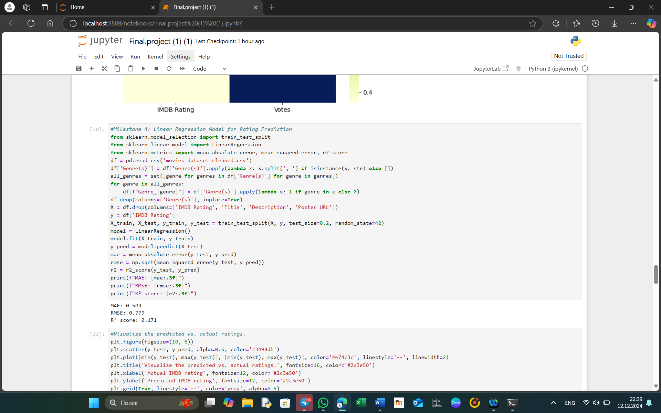
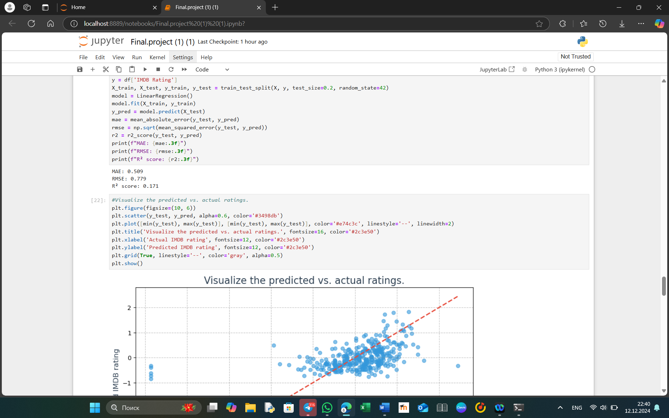
This script builds and evaluates a linear regression model to predict movie ratings (IMDB Rating) and visualizes the model's performance by comparing predicted and actual ratings.

Key Steps:
- Data Preparation:
  - Loads the cleaned dataset (movies_dataset_cleaned.csv).
  - Splits the Genre(s) column into individual genres and creates binary indicator columns (Genre_<genre>), where 1 indicates the presence of the genre.
  - Drops non-numeric and irrelevant columns (Title, Description, Poster URL).
- Feature and Target Selection:
  - Features (X): Includes all numeric columns except IMDB Rating.
  - Target (y): The IMDB Rating column.
- Train-Test Split:
  - Divides the dataset into training (80%) and testing (20%) subsets using train_test_split.
- Model Training:
  - Fits a Linear Regression model using the training data (X_train, y_train).
- Model Evaluation:
  - Predicts ratings (y_pred) using the testing data (X_test).
  - Calculates performance metrics:
    - Mean Absolute Error (MAE): Measures the average magnitude of prediction errors.
    - Root Mean Squared Error (RMSE): Penalizes large errors more heavily.
    - R² Score: Indicates how well the independent variables explain the target variable's variance.
- Visualization of Predictions:
  - Scatter Plot: Compares actual ratings (y_test) with predicted ratings (y_pred):
    - X-axis: Actual IMDB ratings.
    - Y-axis: Predicted IMDB ratings.
    - Points represent individual movies, with transparency (alpha=0.6) for better readability.
  - Identity Line: A dashed red line represents perfect predictions (y_test = y_pred). Points closer to this line indicate more accurate predictions.
  - Customization:
    - Gridlines, title, and axis labels are added with styled fonts and colors.

#Building a Simple Recommendation System
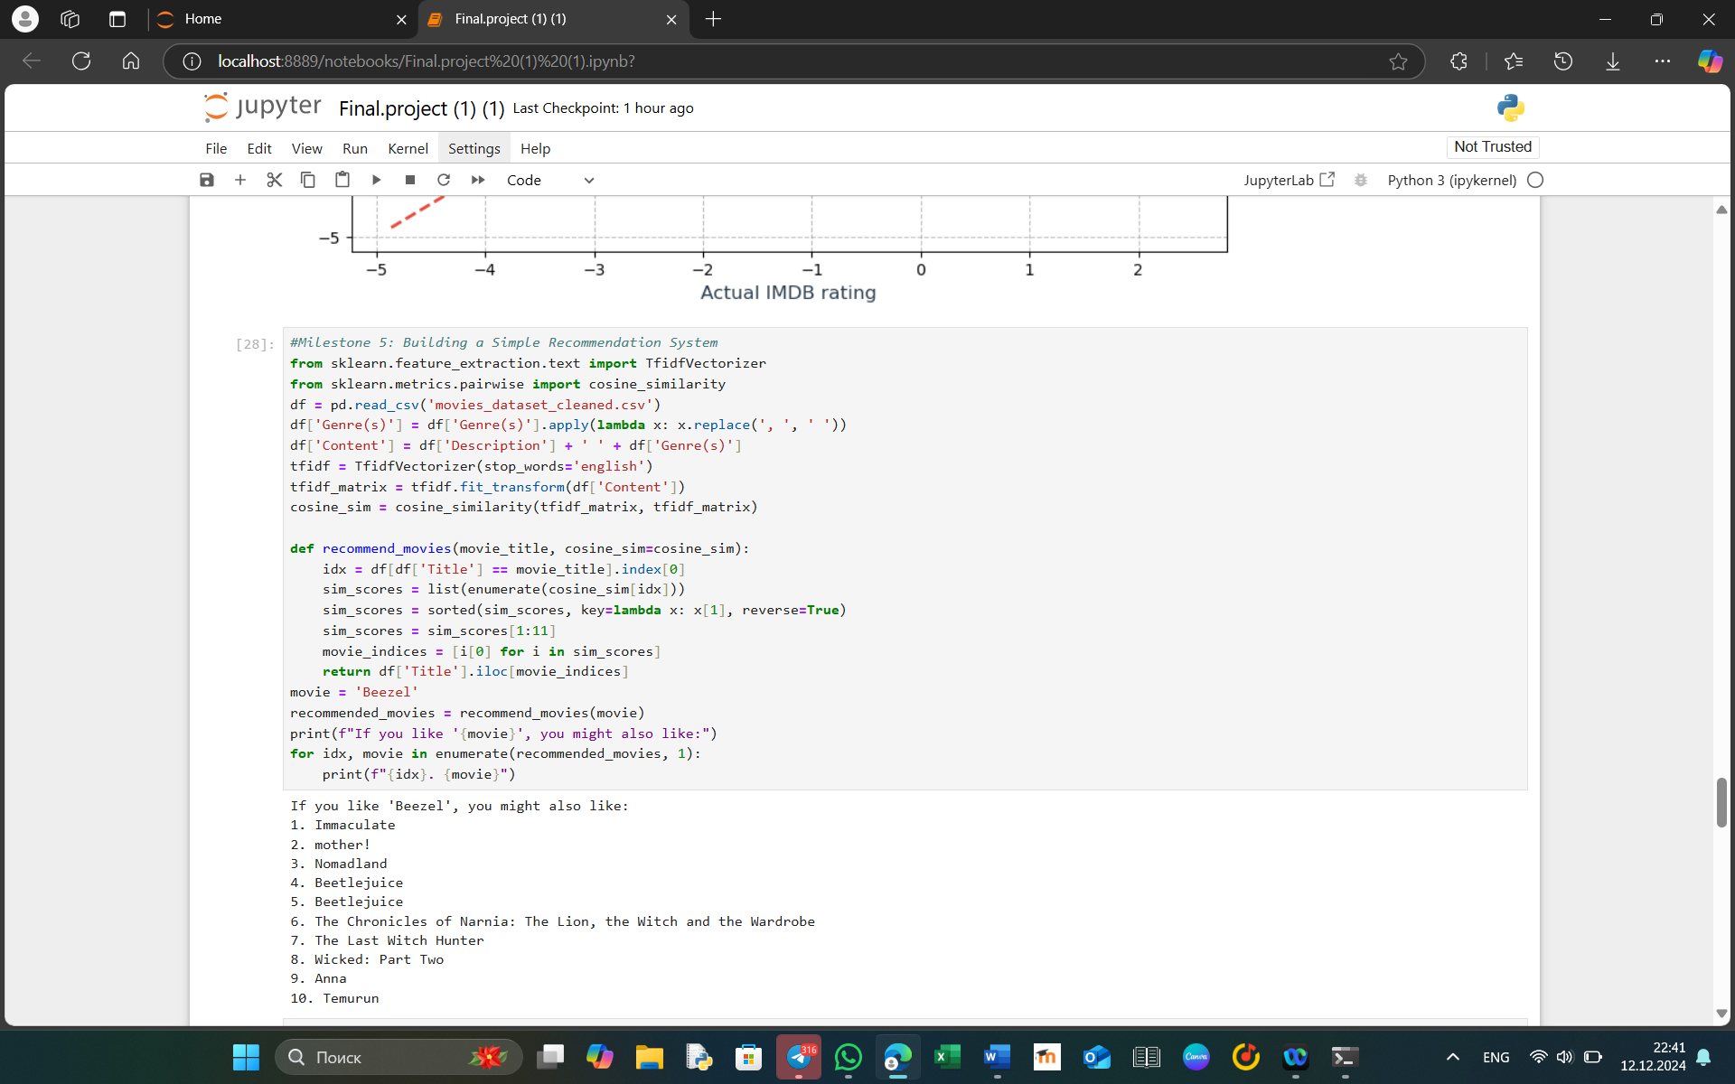
This script implements a content-based recommendation system to suggest movies similar to a given movie based on their descriptions and genres.

Key Steps:
- Data Preparation:
  - Reads the cleaned movie dataset (movies_dataset_cleaned.csv).
  - Combines the Description and Genre(s) columns into a new column called Content.
    - Genres are converted to a space-separated string to facilitate text analysis.
- TF-IDF Vectorization:
  - Uses TfidfVectorizer from sklearn to convert the Content text into a numerical matrix.
    - TF-IDF (Term Frequency-Inverse Document Frequency) captures the importance of words in the context of the dataset while minimizing the impact of commonly used words (e.g., "the", "and").
    - Stop words (common words like "and", "is") are removed using the stop_words='english' parameter.
- Cosine Similarity Calculation:
  - Computes pairwise cosine similarity between movies based on their TF-IDF vectors.
    - Cosine Similarity measures the cosine of the angle between two vectors, effectively quantifying how similar two text contents are.
- Recommendation Function:
  - Input: A movie title (movie_title).
  - Process:
    - Finds the index of the given movie in the DataFrame.
    - Retrieves similarity scores for all movies relative to the input movie.
    - Sorts similarity scores in descending order and selects the top 10 most similar movies (excluding the input movie itself).
  - Output: Titles of the top 10 recommended movies.
- Example Recommendation:
  - If the input movie is 'Beezel', the script identifies and prints 10 similar movies based on their content.

#Data Storage and Access
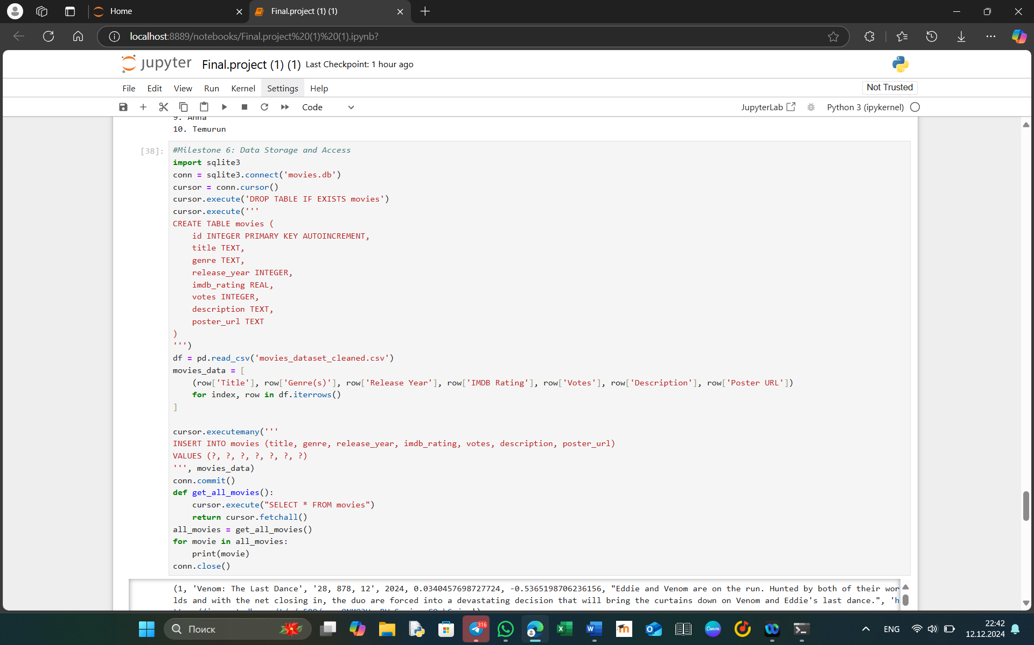
This script provides a complete workflow for storing and accessing movie data in an SQLite database.

Key Features:
- Database Setup:
  - Establishes a connection to an SQLite database file named movies.db.
  - Drops the movies table if it exists to avoid duplicate data during re-runs.
  - Creates a movies table with the following structure:
    - id: Auto-incremented primary key.
    - title: The movie's title.
    - genre: A string containing comma-separated genres.
    - release_year: The year of release.
    - imdb_rating: The movie's IMDB rating.
    - votes: The number of votes the movie received.
    - description: A short synopsis or description of the movie.
    - poster_url: A URL to the movie's poster image.
- Data Ingestion:
  - Reads movie data from the cleaned dataset (movies_dataset_cleaned.csv) using pandas.
  - Converts each row of the DataFrame into a tuple matching the database schema.
  - Inserts all tuples into the movies table using the executemany method for efficient batch processing.
- Data Retrieval:
  - Implements a function get_all_movies() that:
    - Executes a SELECT * FROM movies query to fetch all records from the movies table.
    - Returns a list of tuples where each tuple represents a movie.
- Data Display:
  - Retrieves all stored movies using the get_all_movies() function.
  - Iterates through the result and prints each movie record.
- Database Cleanup:
  - Ensures the database connection is properly closed after all operations to free resources.

#Interactive Interface for Recommendations (Optional)
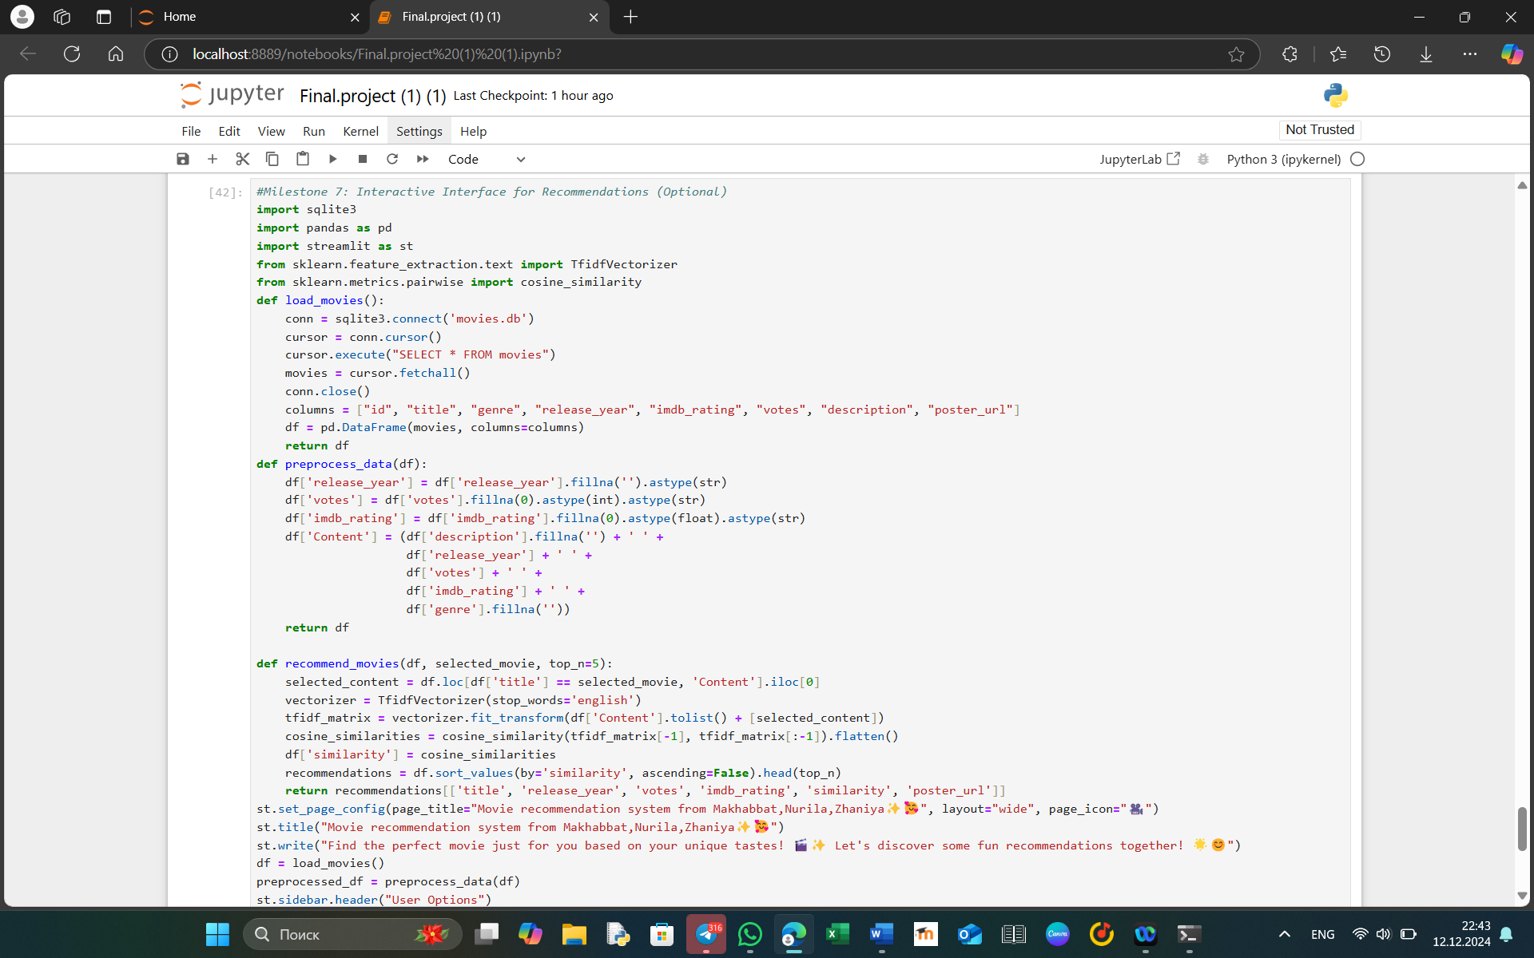
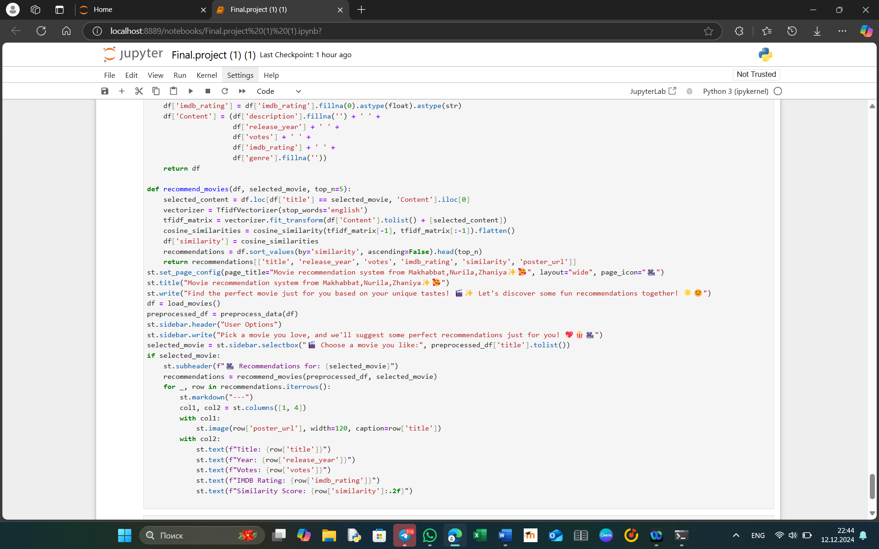
This milestone introduces an interactive movie recommendation system using Streamlit, where users can input a movie they like and receive a list of similar movie recommendations based on content similarity.

Key Features:
- Loading Movie Data:
  - The load_movies() function connects to the SQLite database (movies.db) to retrieve all movie records.
  - It fetches movie details such as title, genre, release year, IMDB rating, votes, description, and poster URL and stores them in a DataFrame.
- Data Preprocessing:
  - The preprocess_data() function prepares the movie data for recommendation. It:
    - Fills missing values for release_year, votes, and imdb_rating.
    - Combines several columns (description, release_year, votes, imdb_rating, and genre) into a single Content column, which will be used to calculate content similarity.
- Movie Recommendation:
  - The recommend_movies() function uses TF-IDF vectorization to compute the cosine similarity between the content of the selected movie and all other movies in the dataset.
  - It returns the top N most similar movies based on the similarity score, including details such as:
    - Movie title
    - Release year
    - Number of votes
    - IMDB rating
    - Similarity score
    - Poster URL
- Streamlit Interface:
  - Streamlit is used to create the interactive interface:
    - A sidebar allows users to select a movie from a dropdown list.
    - Once a movie is selected, the app displays recommendations based on the content similarity.
    - For each recommended movie, the app shows its poster, title, release year, votes, IMDB rating, and similarity score.
- Visualization:
  - Poster Images: Displays a movie poster image beside its details.
  - Recommendation Information: Shows movie details like title, year, votes, IMDB rating, and similarity score.

Interface Design:
- Title: "Movie recommendation system from Makhabbat, Nurila, Zhaniya✨🥰"
- Sidebar:
  - The user selects a movie from the list of available movie titles.
  - Upon selection, the top 5 recommendations (default) are displayed.
- Main Section:
  - Shows the movie poster with essential details for each recommendation, including the similarity score.

